الجمـهـــــوريـــــــــــة الجـزائـريـــــــــــــة الديمـــقــــراطيــــــــــــة الشعبيـــــــــــــة
People`s Democratic Republic of Algeria
Ministry of Higher Education and Scientific Research  National School of Cyber Security |  | وزارة التعــليـــم العــــالــي والــبحـــــث الـعــــلـمـي  المدرســــة الوطنيــــة العليــــا في الأمـن السيبـراني
Foundation Training Department |  | قســـــــم التكويـــــــن القــــــــــاعدي
Level : 1st Year Basic Training  Section / Group : A & B  Module : . . . Network Foundation 1. . . . . . .  Full Name : . . . . . . . . . . . . . . . . . . . . . . . . . . . . . . . . . . |  | Module's Teacher : Pr. Riahla  Date : 26 / 11/ 2025  Duration : 1h30  Note : No documents are allowed.
 | Midterm 1 Test Correction

QCM (Multiple Choices): (0.5 PT BY QST)
- What is the purpose of a network?
- Share and transfer files, folders, printers, etc.
- Sharing database management system and network equipment
- Sharing resources

- Which of the following statements is true about Broadcast mode:
- Cannot avoid collision
- Transmitting multiple data streams over the same communication channel.
- A single collision domain, you can have several communications at the same time without collision.
- Used only by equipment of layer one (OSI model).

- How does packet switching strategy work?
  - It reserves a circuit of communication lines between a sending node and a receiving node for the entire duration of the communication in order to allow data transfer, and releases at the end of the transmission.
  - It divides information into data packets, which are sent independently through intermediate nodes and reassembled at the destination.
  - It transmits the message in a series from one node to the next. Each node waits until it receives the complete message before passing it on to the next.

- Which of the following correctly describes the Synchronous and Asynchronous communication?
  - Asynchronous communication is used in connection-oriented mode, while synchronous communication is used in connectionless mode.
  - In synchronous communication, the data is sent without requesting a connection, while in asynchronous mode the sender requests a connection to the receiver.
  - Both communications can be used in a WI-FI network.
  - No response

- What are the advantages of connectionless connection mode?
  - It is faster because sending data doesn’t require establishing a connection first.
  - It is more complicated
  - It congests the bandwidth
  - No response

- What is the difference between layer two (L2) and layer three (L3) equipment in the OSI model?
  - Layer 2 equipment learns by physical address while L3 equipment uses the physical address to route packets.
  - Layer 2 equipment works by forwarding packets based on their MAC table, while Layer 3 equipment works by broadcasting packets based on their routing table.
  - L3 equipment is more intelligent than L2 equipment
  - No response

- Which protocol allows downloading files?
  - ICMP
  - FTP
  - DNS
  - DHCP

- The physical layer of the OSI model is responsible for :
  - Delivering messages end-to-end across the network.
  - Routing packets based on a unique network address.
  - Standardizing data formats between systems.
  - Defining access procedures to the medium.
  - No response

- Which OSI layer is responsible for encryption?
  - Network
  - Session
  - Presentation
  - Application

- What is encapsulation in networking?
  - The process of removing headers from data
  - The process of adding headers (and trailers) as data moves down the OSI layers
  - The process of encrypting data
  - Converting digital data to analog signals

- What is the correct order of PDU names during encapsulation (top → down)?
  - Bits → Frames → Packets → Segments → Data
  - Data → Segments → Packets → Frames → Bits
  - Data → Frames → Packets → Segments → Bits
  - Frames → Packets → Segments → Data → Bits

- Which addressing type is used in the network access layer of TCP/IP model?
  - Logical
  - Port numbers
  - Physical
  - URL

- Which table is used to forward frames inside a LAN?
  - Routing table
  - ARP table
  - MAC address table
  - NAT table

- When a switch does NOT find a MAC in its table, it will:
  - Drop the frame
  - Act as a Hub
  - Send the frame to a router
  - Broadcast an ARP query

- Which of the following is a disadvantage of connection-oriented communication?
  - No error control
  - Requires connection setup before sending data
  - Does not support reliability
  - No flow control

- Which statement is true about static MAC entries?
  - They are learned automatically
  - They remain in the switch MAC table permanently
  - They increase the size of broadcast domains
  - Prevents unauthorized devices from accessing the network
Exercise 1:
Given the network given bellow:
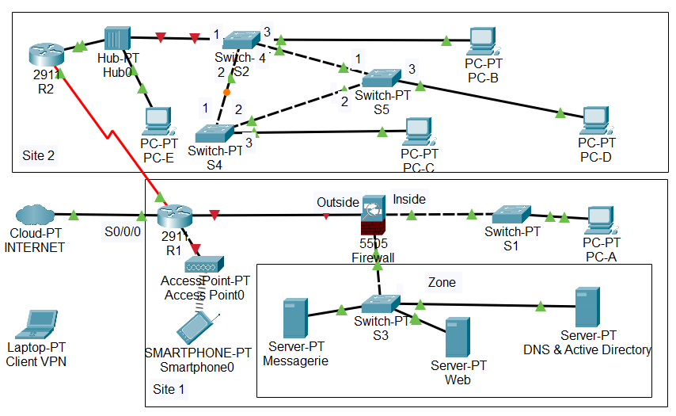
- How many collision domains are there in the diagram? 1PT
17

- How many broadcast domains are there in the diagram? 1PT
6

- Explain the path of the packets in the following cases:
  - When Machine “PC-A” wants to communicate with Machine “Server-PT Web”. 1PT
PC-A sends the packet to switch S1 with @Mac Dest and @IP of server-PT Web. Next, the switch S1 transmits it directly into the Firewall. After that, the firewall controls the packet based on a set of pre-defined security rules: if the packet is permitted to pass, it is directly forwarded to switch 3; otherwise, the packet is stopped. Finally, the switch S3 forwards it directly to the Web server-PT.

  - When “Smartphone 0” wants to communicate to the Internet. 1PT
Smartphone 0 sends the packet to Access Point0 with @Mac Dest of router R1 and @IP of the internet. Next, Access Point0 transmits it directly to the router R1. Next, R1 checks its routing table and forwards the packet to the internet.

  - When “PC-B” wants to communicate with Machine “Smartphone0”. 1PT
PC-B sends the packet with @MAC dest of R2 and @IP of Smartphone to the switch S2. Next, the switch S2 transmits it directly to Hub0, the Hub0 broadcasts the packet to all the connected devices. After that, the router R2 receives the packet and forwards it to R1 according to its routing table. Next, the router R1 receives the packet and forwards it to access point 0 (according to its routing table). Finally, AP0 receives and broadcasts the packet to all the devices

- If the “Hub0” is replaced with a router (R3), draw the routing tables at the level of the routers R1 and R2, and explain the possible routing priorities between Smartphone 0 and PC-D. 1PT
R1:
Destination | Next HOP | Number of hops
PC-D Network | R2 | 2
R2:
Destination | Next HOP | Number of hops
PC-D Network | R3 | 1

- Provide the PDU format (headers) at each layer of the TCP/IP model in the case when user 0 of PC-A with Mac address of 00–01–4B-B2-A4-EF and IP address of 172.16.0.15 tries to send a packet to the Web server. 1PT
Application | HTTP, type of data =text, user 2.
Transport | Source port number, destination port=80
Internet | IP source =172.16.0.15, IP destination=IP of web server-pt.
Network Access | Mac source =00–01–4B-B2-A4-EF Mac destination = Mac @ of concerned interface the Firewall

Exercise 2:
YourEasyShop is an online store that allows customers to browse products and make purchases via a website. Customers enter their username and password on a login page and, after authentication, can view their cart and order history.
- Explain the layers of this architecture using a diagram. 1PT
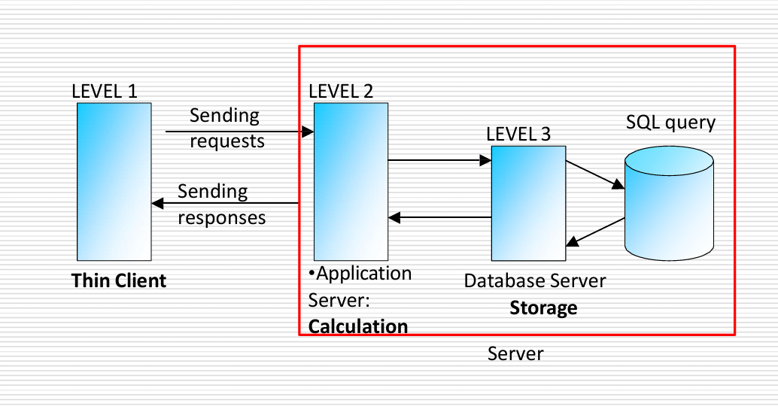
- Presentation Layer : This is the front end of the application, or the user interface, It is responsible for displaying information to the user and accepting user input.
- Application Layer : It receives requests from the presentation layer, processes them, and applies the business rules, It acts as an intermediary, communicating with both the presentation and data layers.
- Data Layer : This the application's data is stored and managed. It is responsible for storing, retrieving, and modifying data in a database or other data storage mechanism. It responds to requests from the application layer.
2. Which connection mode is used, and why? 1PT
Connection- oriented
Because: login credentials (username and password), payment information, and order details must be transmitted accurately. So connection oriented mode ensures :
- No lost packets
- No duplicate packets
- Ordered delivery

- Which switching strategy is used, and why? 1PT
Packet switching
Because , Internet is based on packet switching so there is No need for a dedicated path like circuit switching, nor saturated intermediate nodes such in message switching .

- What are the advantages and disadvantages of this architecture? 1PT
Advantages:
- Thin clients need no installation
- the server is less loaded
Disadvantages :
- architecture exposed to security attacks

- Provide the location of each of the following elements in this architecture: 1PT
- Check if username and/or password are empty (Presentation)
- Transforming the user's query into a SQL query (Application)
- Verify the existence of the user’s account (Data)

